**Cloud Computing MST**

**MODULE – 1 (Introduction)**

1. **Cloud Computing – Overview**
2. What is Cloud Computing
3. Why cloud and characteristics
4. Trends in Computing
5. Distributed Computing
6. Grid Computing
7. Cluster Computing
8. Utility Computing
9. Cloud Computing
10. Cloud services models (Three models)
11. Iaas (AWS ec2, azure)
12. Saas (Google Spread Sheet)
13. Paas (Windows Azure, Heroku)
14. Types of Cloud deployment models
15. Public cloud (Google doc, Spreadsheet)
16. Private cloud (Organization- Window Server)
17. Hybrid cloud (private public- Load balancing)
18. Multi/Community cloud (Shared by several organization-specific goal)
19. **Cloud and Virtualization**
20. Virtualization

* Host machine (VM is going to be build)
* Guest machine (VM is used)
* Hypervisor (Creates & run the VM on physical machine ex. VMM)

1. Type 1 (Bare metal or Native hypervisor)
2. Type 2 (Hosted or embedded)
3. Benefits of Virtualization

* Better resource utilization
* Lower the cost of infrastructure
* Remote access
* Pay as per use model
* Enables run of multiple OS
* One VM will not working then other will not be affected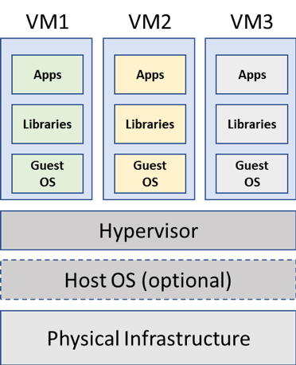

1. Importance and concerns
2. Advantages and disadvantages of Cloud Computing

* Advantages

1. Lower computer cost
2. Collaboration
3. Improved performance
4. Reduced software cost
5. Instant software updates
6. Unlimited storage capacity

* Disadvantages

1. Constant internet connection
2. Does not work with low speed internet connection
3. Features might be limited
4. Can be slow
5. Data might not be secured
6. Different protocols and APIs
7. Not clear that we can run compute intensive application
8. **Cloud Computing Architecture**
9. Cloud architecture

* Mainly two parts (frontend & backed)
* Connected by internet

1. Components of cloud architecture
2. Client infrastructure (frontend -provides GUI to interact)
3. Application (S/w or platform – client want to access)
4. Service (Type of service required- Iaas,Paas,Saas)
5. Runtime cloud (Runtime environment to VM)
6. Storage (Huge amount of Storage capacity to store & manage)
7. Infrastructure (Includes h/w & s/w components-server , storage..)
8. Management (Manages components like application, services)
9. Security (authO,authz)
10. Internet (medium through frontend and backed interacts)

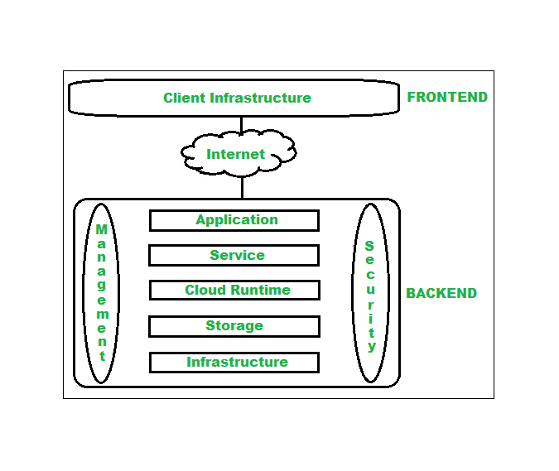

1. **Architecture – Service Models**
2. Xaas (Anything as a service)
3. Saas
4. Paas
5. Iaas
6. **Architecture – Deployment Models**
7. Public cloud
8. Private cloud
9. Hybrid cloud
10. Community cloud

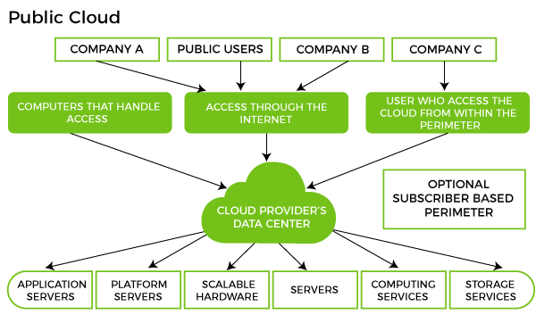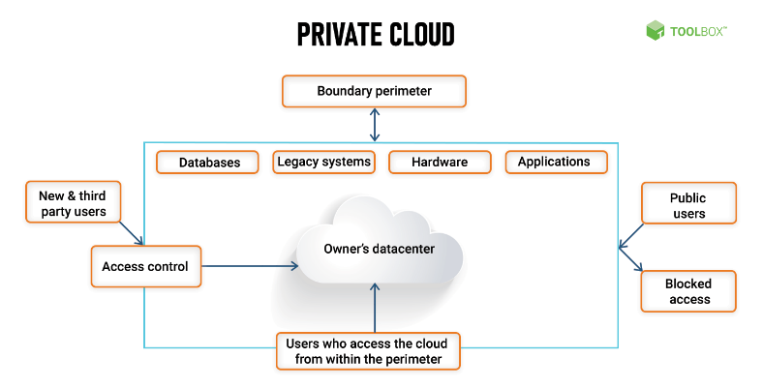

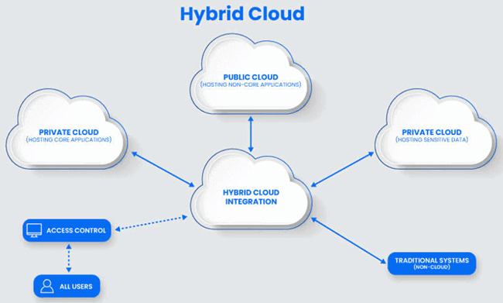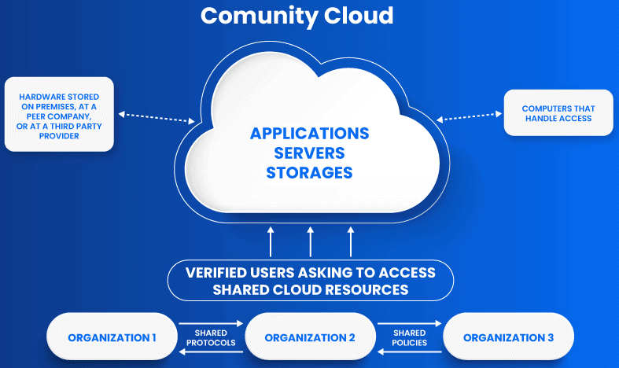

1. **Virtualization**
2. Virtualization (one computer to do the job of multiple computers by sharing resource)
3. Virtual system diagram
4. Hypervisor/VMM
5. **Web Services**
6. Web Services (App. Component that communicates via open protocols(HTTP))
7. Problem solved by web services

* Interoperability (Doesn’t bound to windows only)
* Firewall traversal (Firewall allow access through ports)
* Complexity (Developer friendly)

1. Web service model

* Service Provider (Owner of the service)
* Service Registry (Service provider register there service)
* Service Requestor (Business that requires certain function)

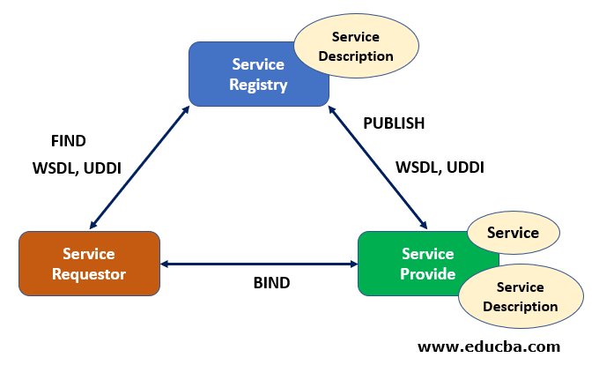

1. Web Service Components

* XML (Extensible Markup Language)
* SOAP (Simple object access protocol)
* WSDL (Web services description language)
* UDDI (Universal description discovery & Integration)

1. All Other from slides

* Web Service Security
* WS-I Basic profile
* WS Atomic transaction
* WSS

1. **Service Oriented Architecture**
2. Role of SOA in CC

* Allows multiple services to communicate & share information
* SOA does this by implementing a method loose coupling.
* Client remain uninterrupted even if the serice changes at any stage.
* SOA is set of multiple services.

1. Improves business workflows

* Access management services
* Ease of monitoring and management
* Easy data exchange
* Interoperability
* Platform neutral approach
* Reliability
* Reusable codes and services
* Service change impact
* Straight forward system integrations

1. Importance of SOA in CC

* SOA integration in cloud environment, reap many benefits like enhanced performance, security, faster deployments, and better monitoring
* With SOA, client does not need to be familiar with any of the underlying programming languages used by the service.
* Independent of products, technologies or vendors.
* For seamless business transition
* Eliminate any complexities of cloud computing integration into your business model.
* SOA makes easier to deploy SaaS in cloud
* SOA and cloud integration makes easier to collaborate within.

**MODULE – 2 (SLA)**

1. **Service Level Agreement (SLA)**
2. SLA (Formal contract b/w a service provider and service consumer)
3. Purpose

* Define a formal basis for performance and availability of SP

1. SLA content

* Set of services will be delivered.
* Complete definition of each service
* Responsibilities of provider and consumer
* Set of metrics to measure servicer provided
* Mechanism to monitor the services
* If terms not satisfy what remedies available
* SLA will change over time.

1. Types of SLA
2. Non Negotiable
3. Negotiable (Negotiable via external agent)
4. SLO (Service level Objective) - Checks multiple parameter

* Availability of service X is 99.9%
* Response time of DB is 3 to 5 sec
* Server peak load time is 0.352sec

1. SLM (Service Level management)

* Monitoring and measuring performance of services based on SLO’s.

1. SLA requirements

* Security
* Data encryption
* Privacy
* Data retention and detection
* Hardware erasure and destruction
* Certification
* Monitoring

1. Limitations

* Service measurement (restricted to optimal %)
* Biasness towards vendors
* Lack of active monitoring on customer side
* No formal way of verify if SLA guarantee are complying or not.